Econometrics Assignment 2b
Joost Bouten, SNR: 1265889
Twan Vissers, SNR: 1266283
Fons Strik, SNR: 1257943

Figure 1: Histogram of number of weeks worked
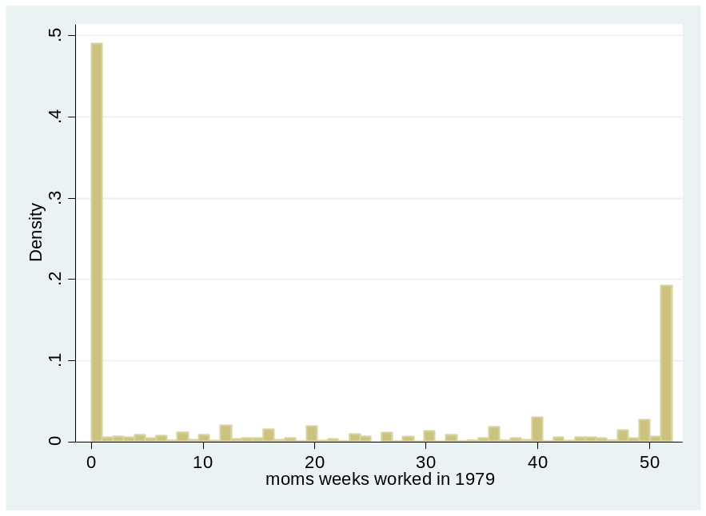

Figure 2: Bar chart of weeks worked by morekids
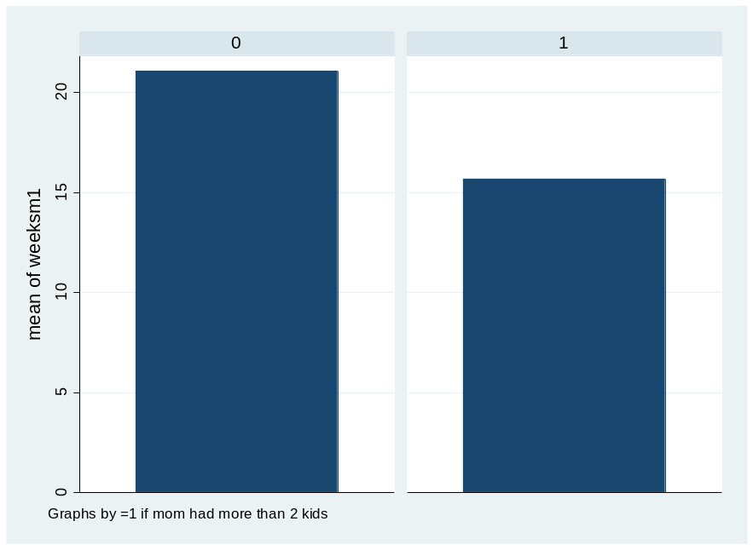
Figure 3: Cumulative Distribution Function
The graph above shows the cumulative distribution function of number of weeks worked for moms that have 2 kids or less (blue) or more than two kids (red).

- We find that the coefficient has a value of -5.3870, and is statistically significant. This suggests that if a mother has had more than two kids, she will on average work $\sim 5.4$ weeks less compared to a mother who has had two kids or less.
- One possible explanation of an omitted variable could be the labor supply of dads. This labor supply could be related to both the treatment as well as the outcome variable. The labor supply of dads could relate to the number of children by the way of the “need to feed” their children. Furthermore, the labor supply of dads is likely to be related to the labor supply of moms. As it might be necessary for one of the parents to be home to look after their children, labor supply of moms and dads may be substitutes. Therefore we conclude that the OLS regression estimated above is inappropriate for estimating the causal effect of fertility on women’s labor supply as there might be an omitted variable bias caused by the omitted variable that is father’s labor supply.

- We regress samesex on morekids to see if there is a significant result for being more likely to have a third kid if the first two kids were of the same sex. We find that the coefficient is positive and equal to 0.0675, significant at the 1%-level. Dividing the coefficient with the mean of morekids gives us a size of 0.1774. We think that …

- According to the independence assumption, the instrumental variable is both independent of the potential outcomes and treatment assignment.

Explain why this same-sex-indicator is a valid instrument for the instrumental variable regression of weeks worked on having two or more children. Discuss both the independence assumption and the exclusion restriction.
